Canada’s Reaction to the Outbreak of War, 2001

Source 1: “Anti-war protesters push peaceful solutions,” Vancouver Sun, Oct. 10, 2001.
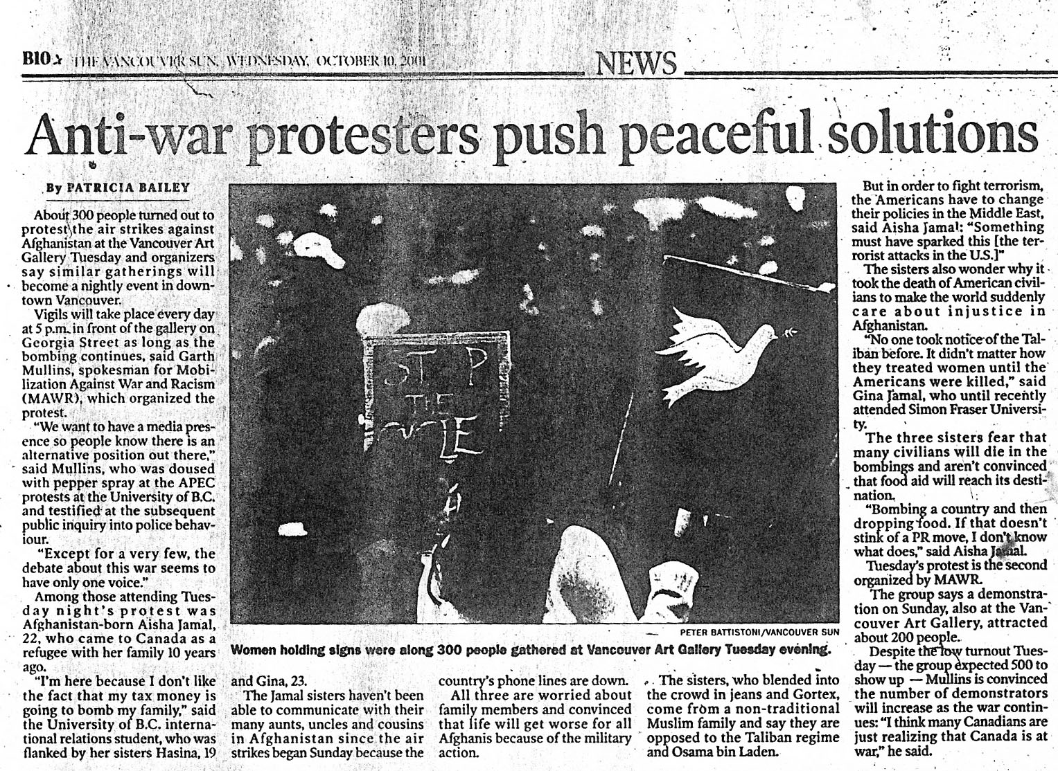

Source 2: Demonstration against participation in Afghanistan war, Toronto, 2001. (“What is Canada's Role in Afghanistan?” Trade Unionists Against The War, http://www.tuaw.ca/, accessed April 17, 2010.)



